Alex Alvarez

Greg Martin

Question One Part A)

1. We downloaded a system called Jalopy2 from Github.
2. Jalopy2 is a Java source code beautifier, the project runs through input files and corrects spacing and tab usage (among other things) in any Java code.
3. The project contains 100,141 lines of code. We found this by using the command “git ls-files | xargs wc -l” in the git bash terminal.

Question One Part B)

1. 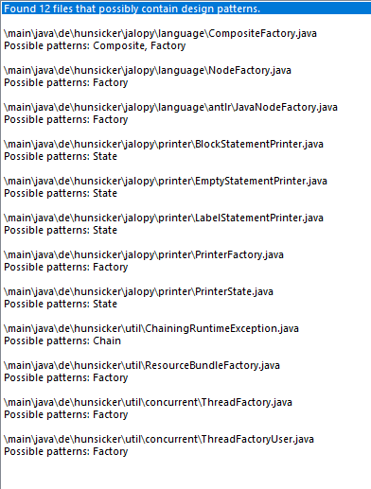
2. TODO
3. TODO

Question Two)